Introduction:

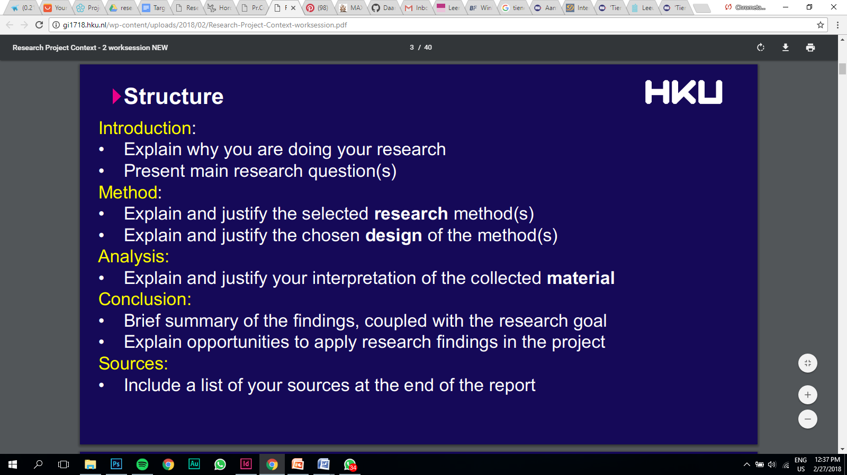In order to make our game appealing to teenagers we first have to look at what their day to day life looks like and what goes on in their mind. We also have to do research into all the factors which can cause stress in teenagers in order to make our game realistic. Our target audience are teenagers. We’ve decided to put our focus on teenagers between the age of 16 and 20 years old, who are in their final year of high school.

There is already a lot of research done on teenagers because adults find it harder to understand what goes on in the life of today’s teenagers. Adults find it hard to keep up with the rise of technology and social media, where teenagers have no problem with it at all. Millennials grew up during the rise of technology and learned how to implement all these new things into their day to day life. As I’m a teenager myself I have no problem knowing what goes on in the mind of a teenager. It is still very helpful to look into other research done on today’s teenagers to get to know new things we maybe didn’t know or couldn’t come up with ourselves.

We mainly want to put our focus on the things that keeps today’s teenagers busy and what, out of those things, could possible cause them any stress. Which aspects, out of the life of a teenager whose in their final year of high school, should we implement into our game to realistically simulate situations where they experience stress and how do we effectively engage them?

Method:

I’ll first start off by looking at the demographics. I’ll look at how much

After knowing all this information I’ll start to look at how I can successfully engage teenagers with our game. By successfully I mean that our game should appeal to our target audience and that they can relate to things that what’s happen in it. I do this by doing research online. I’ll for example look at what apps today’s teenagers use and what these teenagers find interesting to do.

The advantage of using the internet is that I can find a lot research done on big groups of people. In the first method I interviewed people and individually asked them questions. This is primarily quality research. The research I´m doing on the internet is primarily focused on quantity.

I also interviewed a friend of mine who is in their final year of high school. I asked her questions about what causes stress in her life.

Analysis:

The Netherlands is the thirty-first most densely populated country in the world. The 17,000,000 (2017, CBS) Dutch men, women and children are concentrated on an area of 41,526 km²; this means that the country has a population density of 409 per km², or over 502 per km² if only the land area, 33,883 km², is counted 2018, . In the Netherlands alone there live 1.036.434 teenagers from the of 16 to 20 years (2018, CBS). Most of whom live in or near the Randstad. According to a study done by CBS the number of Dutch teenagers will decrease with 160.000 over the course of ten years (2014, CBS). There will be a decrease in big parts of the Netherlands, but an increase in the Randstad (Rotterdam, Amsterdam, Utrecht, Den Haag).

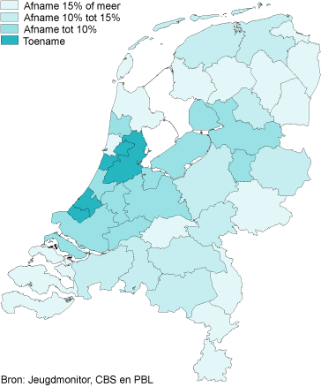

Nowadays teenagers are very obsessive about sharing information via social media. They’re most of the time equally as interested in discovering information as they are sharing it. They prefer content that’s delivered in real time. They want to participate and be involved. Often they are egocentric and care a lot about what other people are thinking. They use social media as a way to show others what their lives look like. They’ll most of the time only share the parts that they want others to know about them. According to a study done by Newcom, Whatsapp is installed on 92% of the smartphones here in the Netherlands and that makes it the most used social media platform used in the Netherlands. While Facebook is very popular amongst adults, Snapchat and Instagram are very popular amongst teenagers.

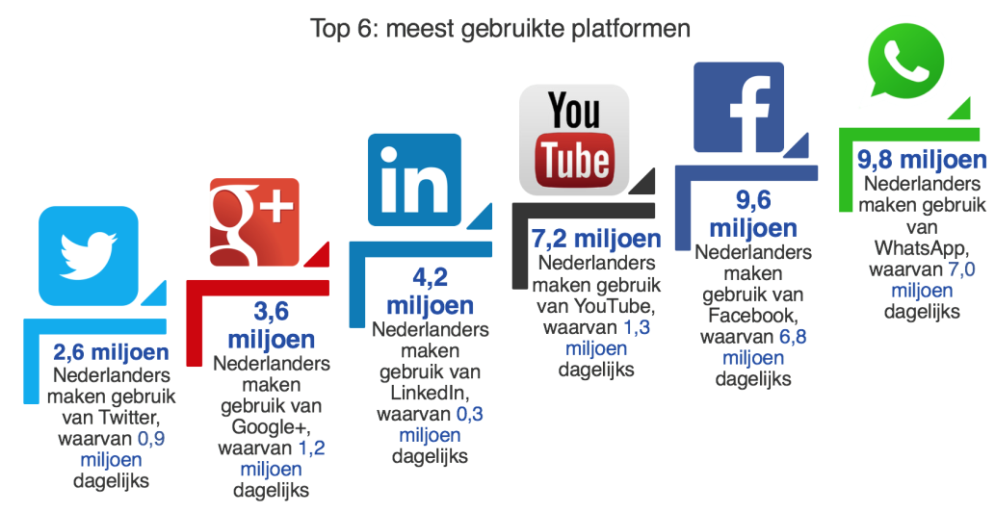

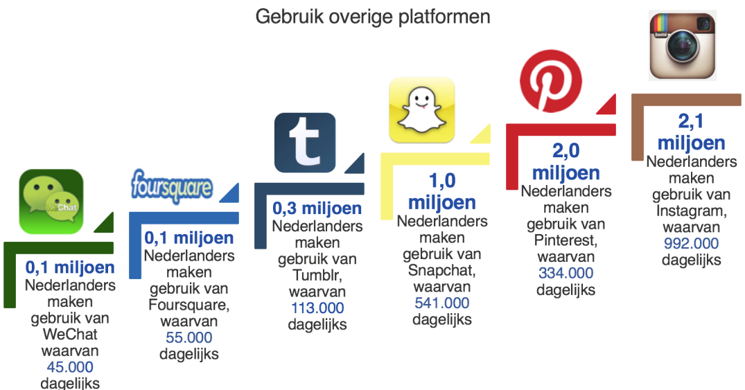  
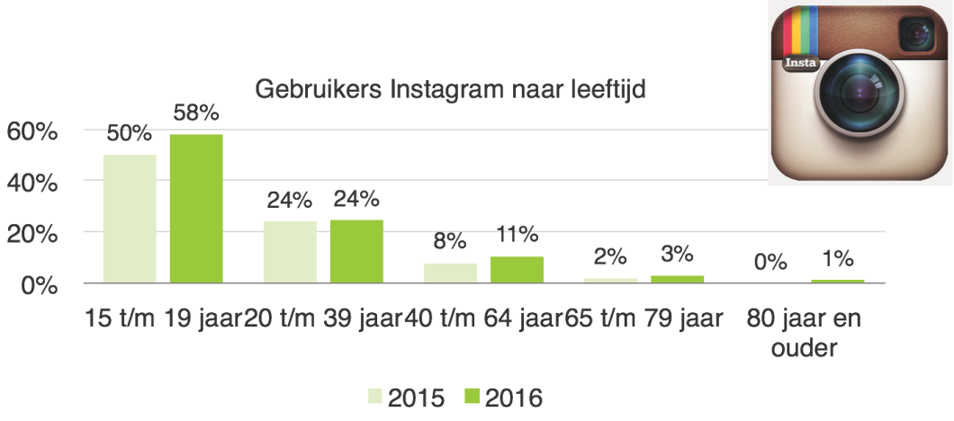

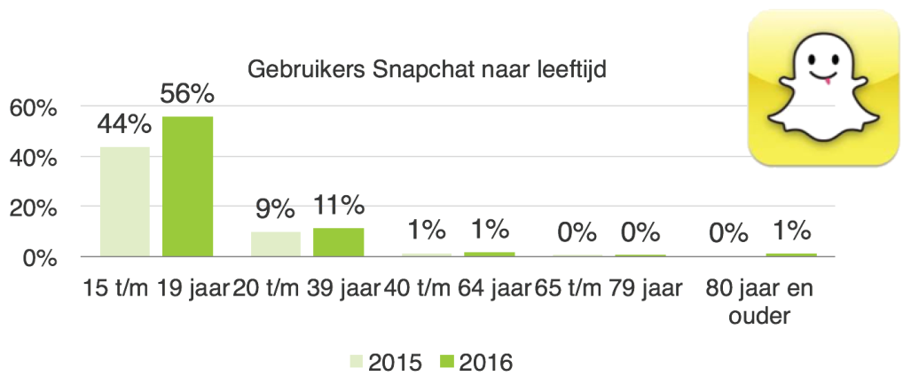

After doing all this research I went out and asked a friend, who is in her last year of high school, what causes her stress. Her name is Melissa. She’s 18 years old and lives in Nijmegen. Melissa told me that the finals caused her a lot of stress. The finals are constantly on her mind if she likes it or not. Because school plays such a big role in her life, she sometimes finds it hard to combine this with her social life. She wants to go out with friends but at the same time she doesn’t want to fall behind with school. She feels a constant pressure to perform well at school and keep the relationship with her friends steady. I also asked her about social media and how much she uses it. She told me that she uses social media a lot. She’ll mainly use it to stay in touch with her friends and acquaintances.

Conclusion:

The amount of teenagers in the Netherlands will decrease in big parts of the Netherlands, but will increase in the big cities. Social media plays a big role in their lives. They share a big part of their lives via social media. They care about what others think about them and use social media as a way to show others the parts of their lives that they think will make them look cool or interesting.

Our game has to include a couple of points in order to appeal to our target audience. Social media plays a big role in the life of a teenager. So it would be smart to include that in our game. Their social life is also something that’s on their mind a lot. Their friends, family and fellow students are all examples of people whose opinion is very important to a teenager. What people think about them is something that’s constantly on a teenager’s mind. Because more and more teenagers are moving to bigger cities we should also take that in consideration when thinking about the location where our game takes place.

<https://www.newcom.nl/socialmedia2016?page=socialmedia2016>

<http://statline.cbs.nl/StatWeb/publication/?VW=T&DM=SLNL&PA=7461BEV&D1=0&D2=a&D3=1-27,101-105,121-123,131&D4=l&HD=110621-1139&HDR=T,G3,G1&STB=G2>

<https://www.cbs.nl/nl-nl/nieuws/2014/40/aantal-tieners-daalt-komende-10-jaar-maar-stijgt-in-randstad>

<http://www.cbs.nl/en-GB/menu/themas/bevolking/cijfers/extra/bevolkingsteller.htm>